Dokumentation

ACRM NICE – SAM Interface
For dormakaba
Stand January 2025

Ralf Sowa
15. Januar 2025
Copyright Powercase Formula CRM GmbH

2 Introduction 3
3 IIS Endpoint for Telephonesearch 4
3.1 Configurationsfile pcfrm_phonesearch.xml 4
3.2 Deployment 4
3.3 Endpointbehavior 5
3.3.1 Endpoint URL 5

Introduction
An endpoint is created in Aurea CRM (SAM) that receives a phone number from NICE and returns a URL that opens a person or company in the CRM if the phone number can be clearly assigned. Otherwise, the person search is opened.

IIS Endpoint for Telephonesearch

Configurationsfile pcfrm_phonesearch.xml
The configuration file can be used to generically specify how the Aurea interface is called. The file is created in XML format. The file's entries are described below.
XML Pfad | Beschreibung
<root><AUREA_INTERFACE><INTERFACEURL> | Aurea Interface URL  Z.B. https://demo.dev.powercasecrm.de/interface/xml
<root><AUREA_INTERFACE><CRMURL> | Aurea Mobile URL  Z.B. https://demo.dev.powercasecrm.de/crm
<root><AUREA_INTERFACE><INTERFACE_USER> | CRM Username  z.B. SU.
<root><AUREA_INTERFACE><INTERFACE_PASSWORD> | Password  z.B. 123456
<root><LOGGING><LOGGING_ON> | If value = 1, then a log file phonesearch_log.txt is created
<root><LOGGING><MAX_SIZE_MB> | Maximum size in MB of the log file
<root><LOGGING><MAX_BACKUPS> | Maximum number of log files. If this is reached, the first file will be overwritten.

Deployment
The ArcmQrCodeWcfService.dll file must be delivered from the .\ pfcrmTelephoneSearch\bin directory.

The Service1.svc and Web.config files must be delivered from the .\ pfcrmTelephoneSearch\ directory.
In addition, the configuration files:

- pcfrm_phonesearch.xml

A new site with a corresponding application pool is created in IIS for this directory.

Endpointbehavior

Endpoint URL
Development | https://telefonsuche.dev.powercasecrm.de/Service1.svc/pfcrm_phone
Dormakaba productive

Request:
http Verb | POST
Headers | 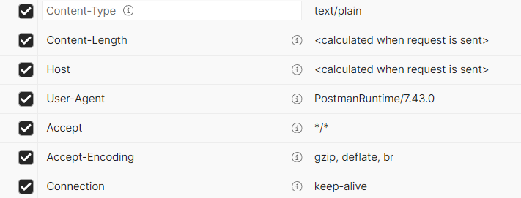
Body | The body contains a JSON object  {  "app_id": "66F00598-59C7-4F3B-A51A-4FE74417B660",  "phonenumber": "491234567890"  }  The app_id is for authification and must be as above.  Phonenumber code das E164. Only numbers, no leading ‘+’

Response:
http Code | Description
200 | Request was succesful  The Body contains a JSON object:  "{  \"url\": https:\/\/demo.dev.powercasecrm.de\/crm\/tree?treeViewName=FI&uid=KP%3Bx0000000100001856  }"  The URL contains the URL of the person or company coresponding tot he searched phonenumber.
401 | Unauthorized access.  Missing or wrong app_id
400 | Bad Request  An error occured

